22BCS093

Prithvi C

**Accelerometer Sensor**

**AIM**:

To create the Accelerometer sensor using the Android studio.

**Activity_main.XML :**

<?xml version="1.0" encoding="utf-8"?>  
<RelativeLayout xmlns:android="http://schemas.android.com/apk/res/android"  
 android:layout_width="match_parent"  
 android:layout_height="match_parent"  
 android:background="#00FF00">  
  
 <TextView  
 android:id="@+id/textViewXx"  
 android:layout_width="wrap_content"  
 android:layout_height="wrap_content"  
 android:text="Accelerometer Sensor"  
 android:textColor="#FF0000"  
 android:textSize="20sp"  
 android:layout_marginTop="20dp"  
 android:layout_centerHorizontal="true"/>  
  
 <TextView  
 android:id="@+id/textViewXxx"  
 android:layout_width="wrap_content"  
 android:layout_height="wrap_content"  
 android:text="Prithvi C 22BCS093"  
 android:background="#00FF00"  
 android:textColor="#0000FF"  
 android:textSize="16sp"  
 android:layout_below="@id/textViewXx"  
 android:layout_marginTop="10dp"  
 android:layout_centerHorizontal="true"/>  
  
 <TextView  
 android:id="@+id/textViewX"  
 android:layout_width="wrap_content"  
 android:layout_height="wrap_content"  
 android:text="X: 0.0"  
 android:textColor="#000000"  
 android:layout_below="@id/textViewXxx"  
 android:layout_marginTop="20dp"  
 android:layout_centerHorizontal="true"/>  
  
 <TextView  
 android:id="@+id/textViewY"  
 android:layout_width="wrap_content"  
 android:layout_height="wrap_content"  
 android:text="Y: 0.0"  
 android:textColor="#000000"  
 android:layout_below="@id/textViewX"  
 android:layout_marginTop="20dp"  
 android:layout_centerHorizontal="true"/>  
  
 <TextView  
 android:id="@+id/textViewZ"  
 android:layout_width="wrap_content"  
 android:layout_height="wrap_content"  
 android:text="Z: 0.0"  
 android:textColor="#000000"  
 android:layout_below="@id/textViewY"  
 android:layout_marginTop="20dp"  
 android:layout_centerHorizontal="true"/>  
  
</RelativeLayout>

**Main_activity.java:**

package com.example.exno8;  
  
import android.hardware.Sensor;  
import android.hardware.SensorEvent;  
import android.hardware.SensorEventListener;  
import android.hardware.SensorManager;  
import android.os.Bundle;  
import android.widget.TextView;  
import androidx.appcompat.app.AppCompatActivity;  
  
public class MainActivity extends AppCompatActivity implements SensorEventListener {  
  
 private SensorManager sensorManager;  
 private Sensor accelerometer;  
 private TextView textViewX, textViewY, textViewZ;  
  
 @Override  
 protected void onCreate(Bundle savedInstanceState) {  
 super.onCreate(savedInstanceState);  
 setContentView(R.layout.*activity_main*);  
  
 textViewX = findViewById(R.id.*textViewX*);  
 textViewY = findViewById(R.id.*textViewY*);  
 textViewZ = findViewById(R.id.*textViewZ*);  
  
 // Initialize the SensorManager and accelerometer sensor  
 sensorManager = (SensorManager) getSystemService(*SENSOR_SERVICE*);  
 if (sensorManager != null) {  
 accelerometer = sensorManager.getDefaultSensor(Sensor.*TYPE_ACCELEROMETER*);  
 }  
 }  
  
 @Override  
 protected void onResume() {  
 super.onResume();  
 // Register the sensor listener when the activity resumes  
 if (accelerometer != null) {  
 sensorManager.registerListener(this, accelerometer, SensorManager.*SENSOR_DELAY_NORMAL*);  
 }  
 }  
  
 @Override  
 protected void onPause() {  
 super.onPause();  
 // Unregister the sensor listener when the activity pauses  
 sensorManager.unregisterListener(this);  
 }  
  
 @Override  
 public void onSensorChanged(SensorEvent event) {  
 // Update the UI with the new accelerometer data  
 if (event.sensor.getType() == Sensor.*TYPE_ACCELEROMETER*) {  
 float x = event.values[0];  
 float y = event.values[1];  
 float z = event.values[2];  
  
 textViewX.setText("X: " + x);  
 textViewY.setText("Y: " + y);  
 textViewZ.setText("Z: " + z);  
 }  
 }  
  
 @Override  
 public void onAccuracyChanged(Sensor sensor, int accuracy) {  
 // Handle accuracy changes if needed  
 }  
}

**output :**

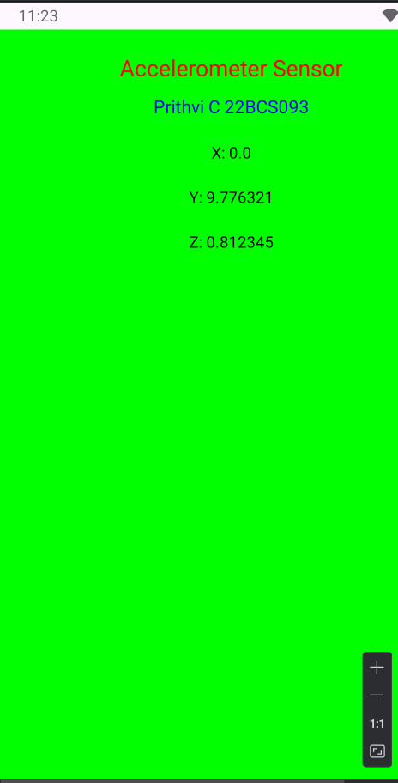

**Result :**

The given task was executed successfully and the output is verified.